EPA PCS_ICIS ECHO Search
The Permit Compliance System (PCS) and Integrated Compliance Information System (ICIS) databases provide information on companies which have been issued permits to discharge wastewater into rivers.

Utah DWQ’s UPDES permit information is currently available in ICIS and includes all Individual UPDES Discharge Permits (Industrial and Municipal) and UPDES General Permits.

All of Utah’s UPDES permit information is made available to the public through EPA’s Enforcement and Compliance History Online (ECHO). The data on ECHO is refreshed weekly, typically on Saturday. For more information, visit the ECHO FAQs:
https://echo.epa.gov/resources/general-info/echo-faq
ECHO Website:
https://echo.epa.gov

To search for UPDES Permits in Utah, go to the ECHO Website above and search by Location or Facility Name/ID under the “Quick Search” tab. For advanced searches aelect “Search Options”
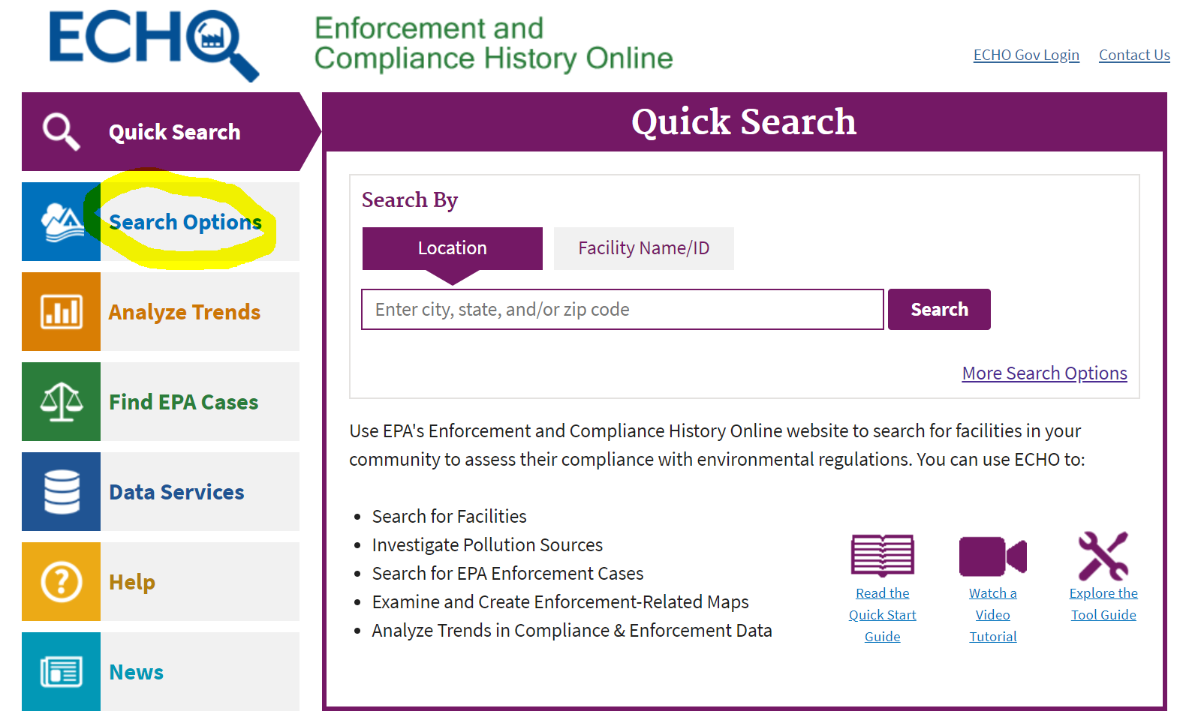
Under Water, select Water Facility Search:
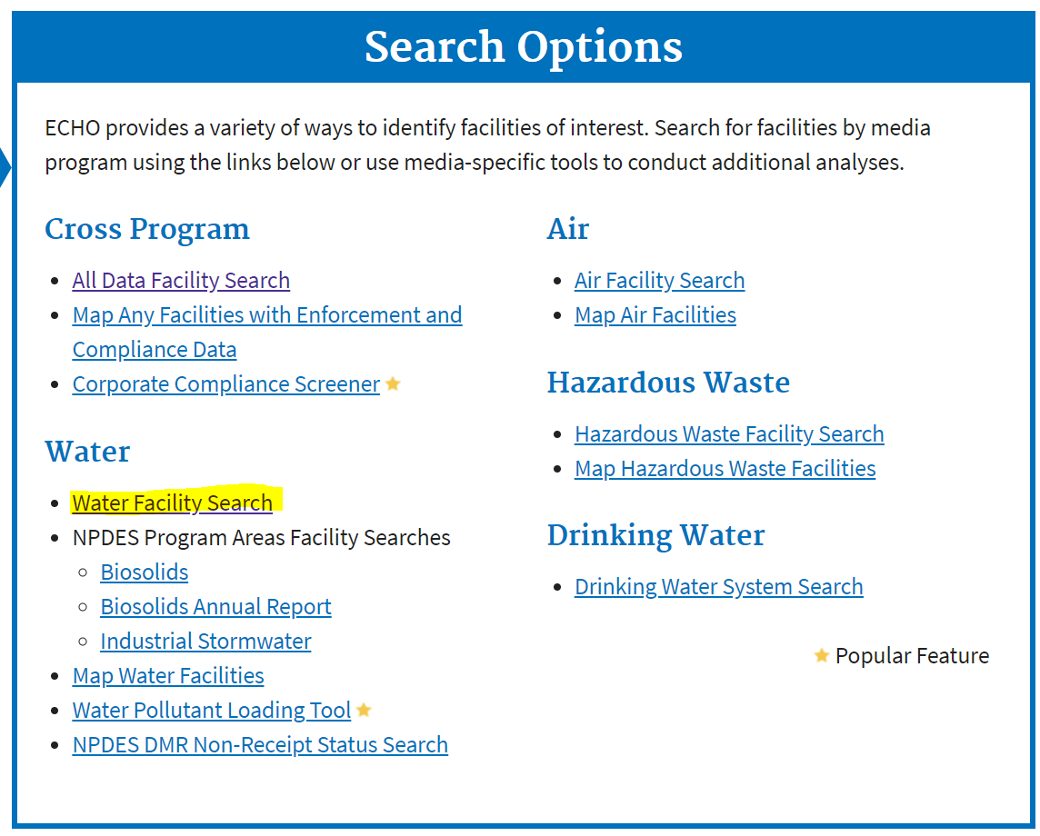

Select ‘Water’ under search type and ‘Utah’ for State:
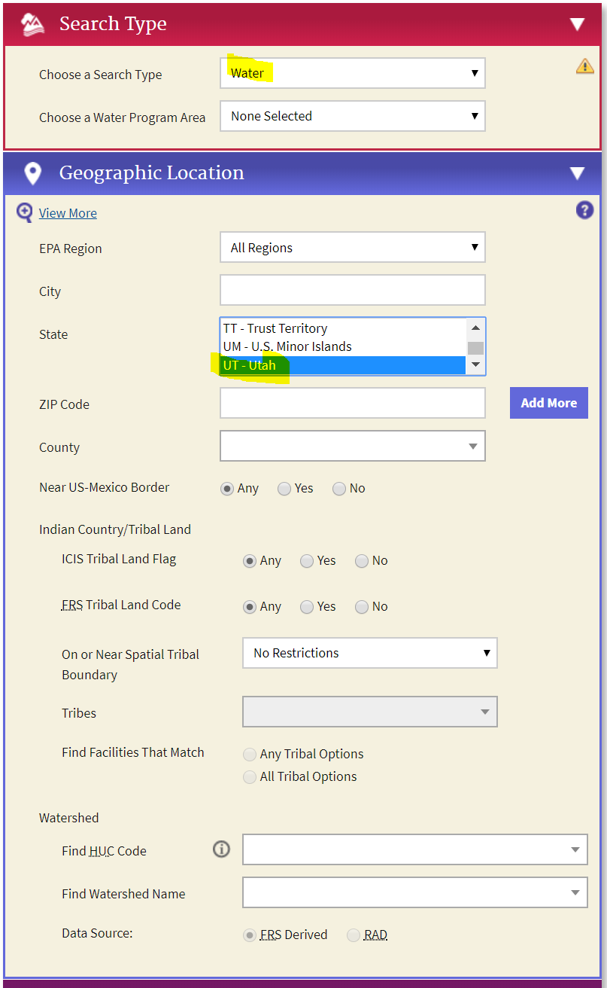

Customize your search using Facility Characteristics. Enter the UPDES Permit Number as the Facility ID Number, specify permit status, permit type and/or permit components:

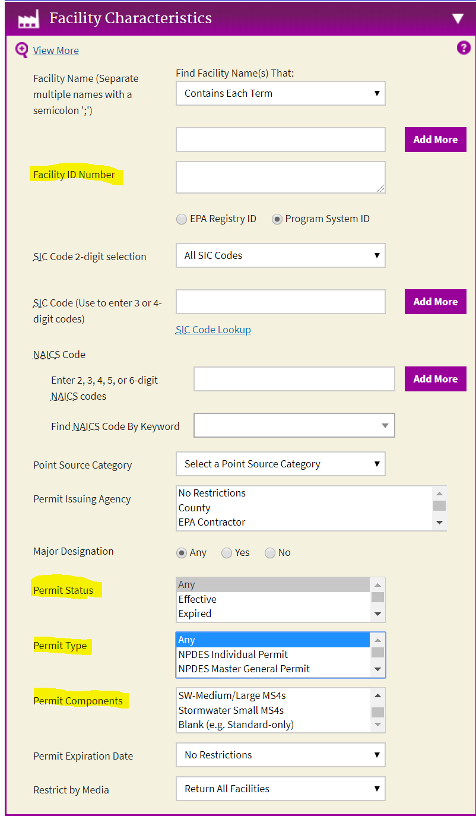

Select ‘Data Table’ as the Result View option:
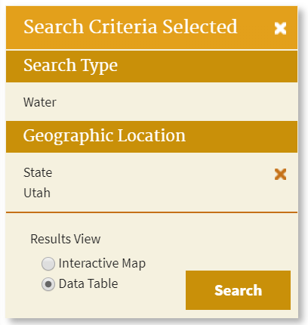
Select the Customize Columns Button to specify columns of data you would like to export. Most of the parameters under Permits should be selected for UPDES permits. Next, select the Download Data button to export the file.
